|  |  |
| --- | --- |
|  | **BAHRIA UNIVERSITY**  **(Karachi Campus)**  *Department of Software Engineering*  **ASSIGNMENT#02 – Fall 2023** |

|  |  |  |  |
| --- | --- | --- | --- |
| COURSE TITLE: | **Information Security** | COURSE | CODE: **CSC-407** |
| Class: | **BSE – 7A&7B** | Shift: | **Morning** |
| Course Instructor: | **DR. OSAMA REHMAN** | Date: | **05-Dec-2023** |
| Due Date: | **15-Dec-2023** | Marks: | **7.0 Marks** |
| **Instructions:** |  |  |  |

# Attempt all questions.

1. **This is an individual effort task.**
2. **Only handwritten answers are accepted (applicable is writing descriptions in Q1, Q2).**
3. **Write your full name, registration number and section on the title page.**
4. **Questions#1, 2 and 3 are CEPs having attribute of no obvious solution.**

Q1. Install an Antivirus of your own choice over your personal smartphone device and perform a “Full / Deep / Root” scan on it. Afterwards, do the following: **[CLO#3, CEP, 2.0 marks]**

1. Mention the name of the Antivirus of your choice along with providing justifications regarding the choice. Provide one snapshot of the installed antivirus.

**Avast Anitvirus**

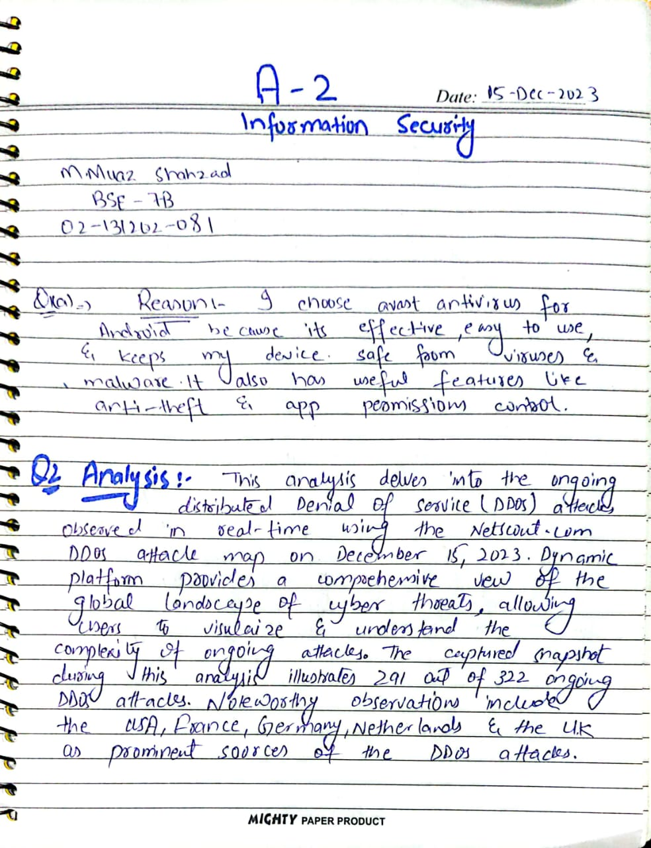

1. In case one or more malwares have been detected in the scanning processing, list those malware types / names. In case no malware has been detected, mention that no malware has been detected and put a snapshot of the virus scanning result.  
     
   **No Malware has been detected.**

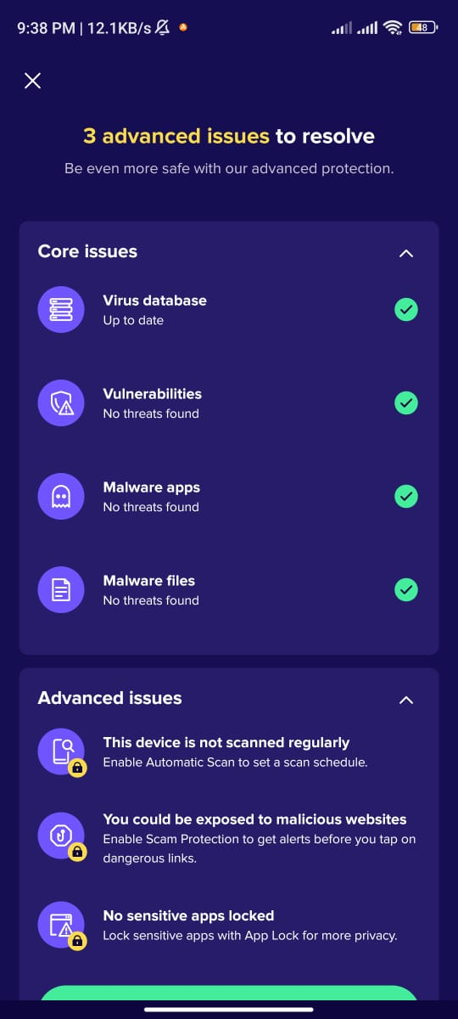

Q2. While using an Online DDoS Attack Map, write a one-page analysis report of your observations of the on-going DDoS attacks, where you may take into account several factors such as attack sources, attack destinations, attack volumes, etc. Mention the name and link for the attack map website along with providing a snapshot of the map taken at the time of on-going DDoS attacks. **[CLO#4, CEP, 2.0 marks]**

**Solution**



Q3. Take a set of 10 MS Word files having some text saved in it. Generate the Hash values of each file by using MD5 hash algorithm and generate a database *(e.g. an Excel sheet)* that would save the hash values of these 10 files. Ask anyone else, e.g. family members or friends, to pick up any 2~5 files randomly and make a minor change in the content *(e.g. single character change)* without you knowing of which files have been changed. By using the same MD5 hashing technique, find out which files have been changed, while reporting the old hash values and new hash values along with the name of changed files.

**Solution:** After randomly changing a single character in files, I observed that the hash values for files 1, 4, 7, and 9 have changed.

